

***School of Mechanical & Manufacturing Engineering (SMME),***

***National University of Science and Technology (NUST),***

***Sector H-12, Islamabad***

Program: BE-Aerospace Section: AE-01

Session: Spring 2024 Semester: 2nd

Course Title: Engineering Drawing AE-103

Project

***“3D Model of a Jet with Assembly”***

***Name: IKHLAS JAMSHAID***

***CMS:*** 454122

**OBJECTIVE**Top of Form

The objective of my project was to design and assemble a jet using AutoCAD. This involved creating individual components of the jet and integrating them into a final assembly. My aim was to demonstrate proficiency in AutoCAD's 3D modeling tools, assembly techniques, and detailed documentation of the design process.

**DEFINITIONS:**

* **3D Modeling**: The process of creating a mathematical representation of a three-dimensional object using specialized software.
* **Assembly**: The process of combining individual components into a complete and functional product.
* **Extrusion**: A technique used in CAD to extend a 2D shape into the third dimension, creating a 3D object.
* **Union and Subtract**: Tools in AutoCAD used to combine or remove material from 3D shapes.
* **Constraints and Dimensions**: Parameters used to control the size, shape, and relationships between parts to ensure they fit together correctly.
* **Mesh Box:** Creates a rectangular box-shaped mesh. You can specify the length, width, and height.
  + **Mesh Cylinder:** Creates a cylindrical mesh with a specified radius and height. The number of divisions along the height and around the circumference can also be set.
  + **Mesh Cone:** Generates a cone-shaped mesh. The base radius, height, and top radius (if different from zero) can be specified.
  + **Mesh Sphere:** Creates a spherical mesh. The radius and the number of longitudinal and latitudinal divisions can be defined.
  + **Mesh Pyramid:** Constructs a pyramid-shaped mesh. You can specify the base dimensions, height, and the number of sides for the base.
  + **Mesh Wedge**: Produces a wedge-shaped mesh. The dimensions of the base and the height can be set.

**KEY CONCEPTS:**

* **Solid Modeling**: Involves creating a solid representation of the object, including all details and features.
* **Parametric Design**: Using parameters to define and control the dimensions and geometry of the model.
* **Boolean Operations**: Techniques such as union, subtract, and intersect used to combine or modify 3D shapes.
* **Layer Management**: Organizing different parts of the model into layers for easier management and modification.
* **Detailed Documentation**: Recording the design process, decisions, and specifications to ensure the model can be accurately replicated or modified.

**PROCEDURE**

Following the video tutorial provided, here is the step-by-step procedure I followed for creating the jet assembly:

**Step 1: Creating the Main Body**

1. **Set Up the Workspace**: I opened AutoCAD and set up the workspace for 3D modeling by switching to the 3D Modeling workspace.
2. **Draw the Base Profile**: Using the Line and Arc tools, I created the outline of the jet’s main body in the front view. I ensured the profile was closed.
3. **Extrude the Profile**: I selected the closed profile and used the Extrude tool to extend it along the desired length, forming the main body of the jet. I specified the extrusion distance to match the desired length of the jet.

**Step 2: Designing the Wings**

1. **Draw the Wing Profile**: In the top view, I drew the outline of one wing using the Line and Arc tools. The profile included the leading edge, trailing edge, and any necessary curves or angles.
2. **Extrude the Wing**: Using the Extrude tool, I gave the wing a 3D shape, specifying a consistent thickness for the entire wing.
3. **Mirror the Wing**: I used the Mirror tool to create an identical wing on the opposite side of the jet. I selected the wing profile, defined the mirror line along the center of the jet, and ensured the copied wing was accurately positioned.

**Step 3: Crafting the Tail**

1. **Draw the Tail Profile**: In the side view, I sketched the vertical and horizontal stabilizers. The vertical stabilizer was perpendicular to the body, while the horizontal stabilizers extended from the tail section.
2. **Extrude the Stabilizers**: I used the Extrude tool to add depth to both the vertical and horizontal stabilizers. I ensured the extrusion was symmetrical and consistent.
3. **Union the Stabilizers**: I used the Union tool to combine the stabilizers with the main body of the jet. This ensured the tail was securely attached and formed a single solid piece with the body.

**Step 4: Detailing the Jet Engines**

1. **Create the Engine Cylinders**: I used the Cylinder tool to create the basic shape of the jet engines. I specified the diameter and height of the cylinders to match the scale of the jet.
2. **Position the Engines**: I placed the engines at the rear of the jet, ensuring they were symmetrically aligned with the body. I used the Move tool to adjust their position as needed.
3. **Detail the Engines**: I added additional shapes such as cones and spheres to represent the intake and exhaust sections. Using the Subtract tool, I removed material where necessary, creating realistic engine details.

**Step 5: Designing the Cockpit**

1. **Draw the Cockpit Profile**: In the front view, I sketched the outline of the cockpit area, including the canopy and frame.
2. **Extrude the Cockpit**: I used the Extrude tool to create the 3D shape of the cockpit. I ensured the extrusion followed the curvature of the main body.
3. **Add Details**: I used additional shapes such as boxes and cylinders to add details like the cockpit frame, instrument panels, and seats.

**Step 6: Final Assembly and Adjustments**

1. **Position All Components**: I moved all parts (wings, tail, engines, cockpit, landing gear) into their correct positions relative to the main body.
2. **Union All Parts**: Using the Union tool, I combined all parts into a single assembly. This ensured the jet model was a cohesive unit.
3. **Add Fillets and Chamfers**: I applied Fillet and Chamfer tools to edges where necessary to give the jet a finished look and improve aerodynamics.
4. **Check Dimensions and Constraints**: I verified that all parts were correctly dimensioned and fit together as intended. I used dimensioning tools to measure and adjust any discrepancies.
5. **Adjust as Necessary**: I made any required adjustments to improve the design or fix issues. This involved resizing parts, repositioning components, or modifying profiles.

**SCREEN SHOTS**

***1:***

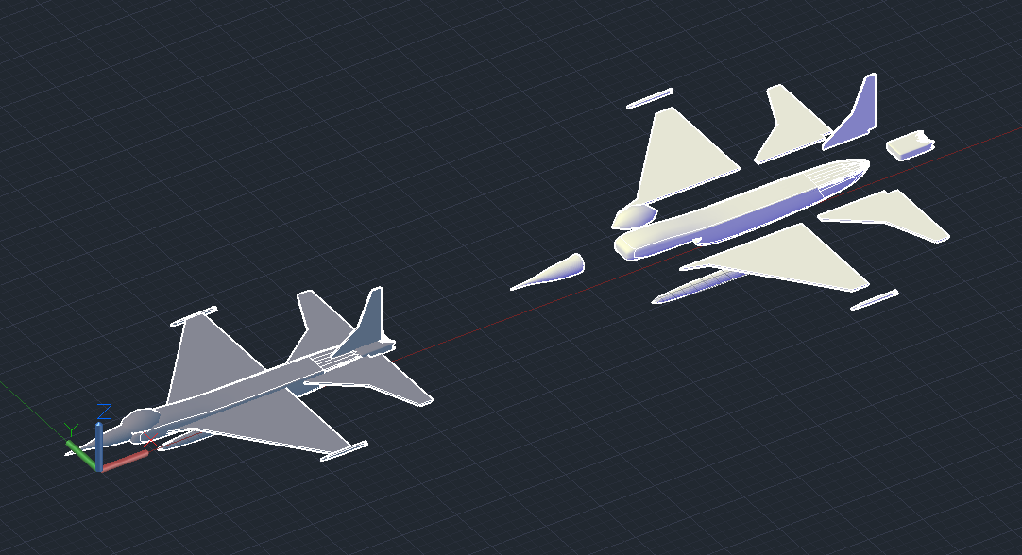

Figure With and without assembly

***2:*** 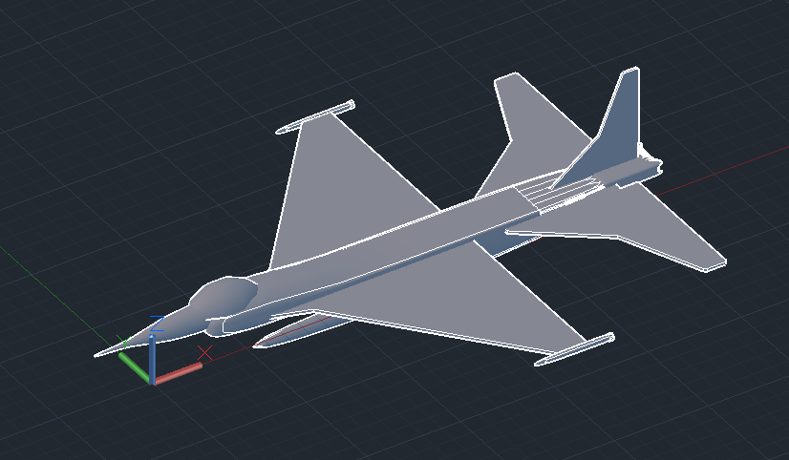

Figure Fully defined Assembly

***3:***

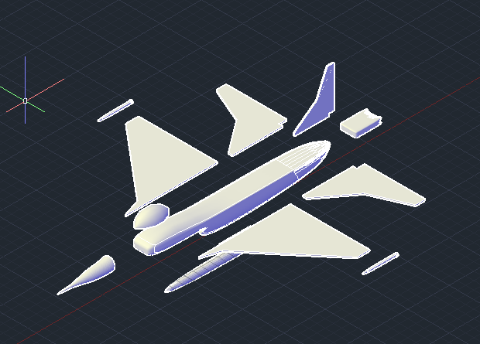

Figure Parts without Assembly

**CONCLUSION**

This project provided an opportunity for me to explore various features and tools within AutoCAD for 3D modeling and assembly. By following the tutorial, I developed a comprehensive understanding of creating complex models and assemblies. The final jet model demonstrates the application of solid modeling techniques, assembly methods, and detailed documentation in AutoCAD, successfully reflecting the project's objective. The process involved careful planning, precise execution, and iterative refinement, culminating in a detailed and accurate representation of a jet.

# References

https://www.youtube.com/watch?v=wx1CCH71pPs&t=24s&ab_channel=Autocadandcivilengineering

